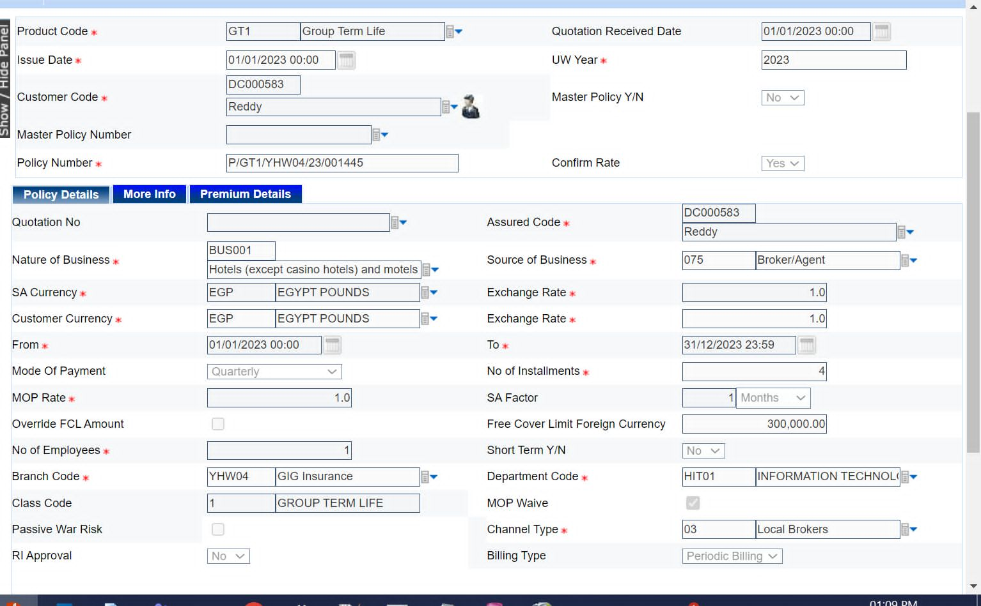

create table SK_POLICY
(
Prod_code varchar2(25),
Issue_Date date,
Cust_code varchar2(25),
Mast_pol_num number,
policy_number varchar2(25),
Quotati_redate date,
Uw_year date,
master_policy char(1),
confim_Rate char(1),
constraint master_check check(master_policy in ('y','n')),
constraint confim_Rate_check check(confim_Rate in ('y','n')),
Quotation_no number(20),
Natural_of_business varchar2(25),
SA_currency varchar2(30),
From_date date,
Mode_of_pay varchar2(25),
Mop_Rate number(10),
--- over_ride,
No_of_employees number(10),
Brach_code varchar2(25),
Class_Code varchar2(25),
RI_Approval char(1),
constraint RI_Approval_check check(RI_Approval in ('y','n')),
Assured_code varchar2(20),
source_of_Business_number varchar(25),
source_of_business char(10),
constraint source_of_Business_r_check check(source_of_business in ('Broker','agent')),
Exchange_Rate number(10),
To_date_policy date,
No_of_installments number(10),
--SA Factor
Free_cover_limit_FC number(20),
Short_Term char(10),
constraint Short_check check(Short_Term in ('no','Yes')),
Department_code number(10),
--Mop walve
source_of_business_bill char(100),
channel_Type number(10),
constraint Billing_type_check check( source_of_business_bill in ('periodic_Billing','billing')),
Fc_Sum_Assured number(25),
no_of_Members number (25),
no_of_Members_Above_fcl number(10),
no_of_dependents number(10),
Free_cover_Limit number(25),
foreign_currency_premium number(10),
Extra_Premium number(10),
Total_Discount number(10),
Total_charges number(10),
Net_Premium number(10),
single_Time_Charge number(10),
First_Premium number(10));

INSERT INTO SK_POLICY
(
Prod_code,
Issue_Date,
Cust_code,
Mast_pol_num,
policy_number,
Quotati_redate,
Uw_year,
master_policy,
confim_Rate,
Quotation_no,
Natural_of_business,
SA_currency,
From_date,
Mode_of_pay,
Mop_Rate,
No_of_employees,
Brach_code,
Class_Code,
RI_Approval,
Assured_code,
source_of_Business_number,
source_of_business,
Exchange_Rate,
To_date_policy,
No_of_installments,
Free_cover_limit_FC,
Short_Term,
Department_code,
source_of_business_bill,
channel_Type,
Fc_Sum_Assured,
no_of_Members,
no_of_Members_Above_fcl,
no_of_dependents,
Free_cover_Limit,
foreign_currency_premium,
Extra_Premium,
Total_Discount,
Total_charges,
Net_Premium,
single_Time_Charge,
First_Premium
)
VALUES
(
'PRD001', TO_DATE('2025-01-01','YYYY-MM-DD'),'CUST001',1001,'POL001',TO_DATE('2024-12-15','YYYY-MM-DD'),TO_DATE('2025','YYYY'),'y','n', 50001,'Health',
'USD',TO_DATE('2025-01-01','YYYY-MM-DD'), 'Monthly',5, 250,'BR001',
'CL001','y', 'AS001', 'SB001','Broker',1.25, TO_DATE('2025-12-31','YYYY-MM-DD'),12, 100000,'no',10,'periodic_Billing',1, 500000,300, 50, 120,200000, 1500,
200, 3 400, 10000,100, 2000);

secod column
INSERT INTO SK_POLICY
(
Prod_code,
Issue_Date,
Cust_code,
Mast_pol_num,
policy_number,
Quotati_redate,
Uw_year,
master_policy,
confim_Rate,
Quotation_no,
Natural_of_business,
SA_currency,
From_date,
Mode_of_pay,
Mop_Rate,
No_of_employees,
Brach_code,
Class_Code,
RI_Approval,
Assured_code,
source_of_Business_number,
source_of_business,
Exchange_Rate,
To_date_policy,
No_of_installments,
Free_cover_limit_FC,
Short_Term,
Department_code,
source_of_business_bill,
channel_Type,
Fc_Sum_Assured,
no_of_Members,
no_of_Members_Above_fcl,
no_of_dependents,
Free_cover_Limit,
foreign_currency_premium,
Extra_Premium,
Total_Discount,
Total_charges,
Net_Premium,
single_Time_Charge,
First_Premium
)
VALUES
(
'PRD002',TO_DATE('2025-02-01','YYYY-MM-DD'),'CUST002',2002, 'POL002', TO_DATE('2025-01-15','YYYY-MM-DD'),TO_DATE('2025','YYYY'),'y',
'y',60002,'Life','INR',TO_DATE('2025-02-01','YYYY-MM-DD'),
'Yearly', 10,150, 'BR002', 'CL002', 'n', 'AS002', 'SB002','agent',1.00,TO_DATE('2026-01-31','YYYY-MM-DD'),
1,200000, 'no', 20, 'billing', 2,750000,400,80,200,300000, 0,500,1000, 700,15000,250,14500);

